MongoDB - Array function

By Madhav gupta

Write a MongoDB aggregation query to fetch only the top mark of each student.

db.stu2.aggregate([{$project:{name:1 , topmarks:{$maxN:{input:"$marks" , n :1}}}}])

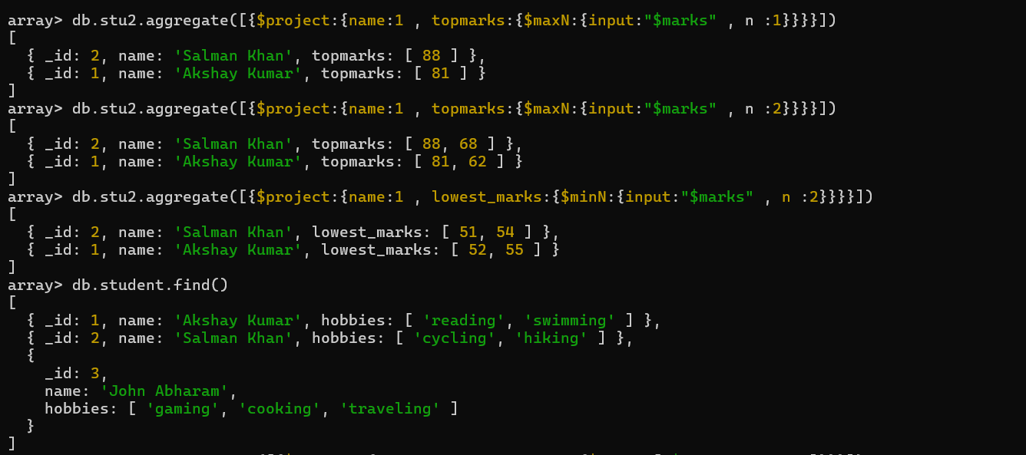

How would you modify the previous query to fetch the top 2 marks instead?

db.stu2.aggregate([{$project:{name:1 , topmarks:{$maxN:{input:"$marks" , n :2}}}}])



Write a query to get the 2 lowest marks of each student from the marks array.

db.stu2.aggregate([{$project:{name:1 , topmarks:{$minN:{input:"$marks" , n :2}}}}])



db.student.find()



Write a query to select the first 2 hobbies from the hobbies array.

db.student.aggregate([{$project:{name:1 , selecthobies:{$slice:["$hobbies", 1, 2]}}}])

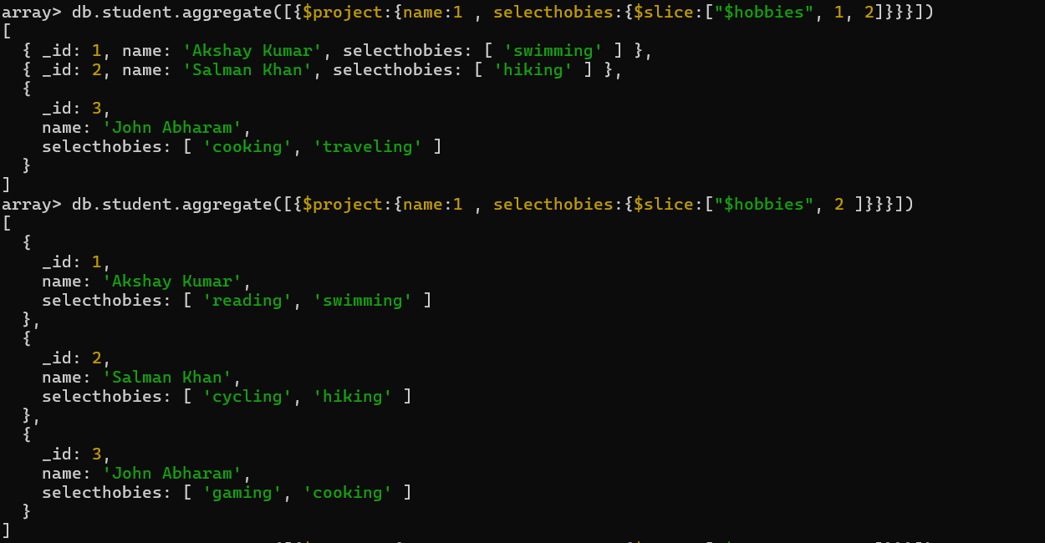

Write a query to return only hobbies starting from index 1, taking 2 hobbies total.

db.student.aggregate([{$project:{name:1 , selecthobies:{$slice:["$hobbies", 2 ]}}}])



How would you extract the first 3 elements of the hobbies array regardless of array length?

db.student.aggregate([{$project:{name:1 , selecthobies:{$slice:["$hobbies" ,0, 3]}}}])

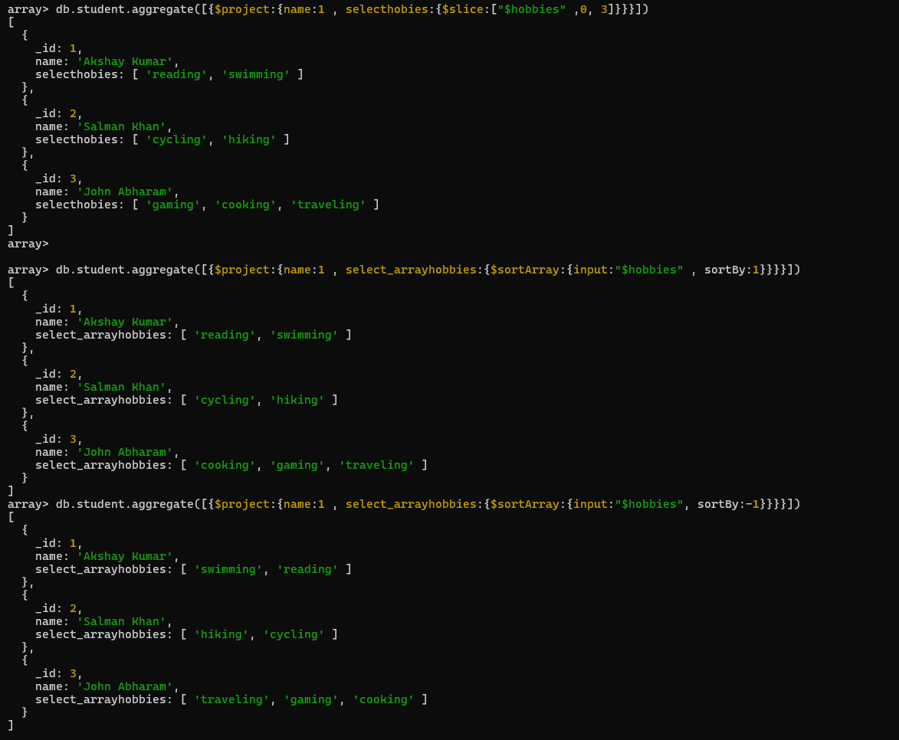

Write a query to sort each student's hobbies array in ascending order.

db.student.aggregate([{$project:{name:1 , select_arrayhobbies:{$sortArray:

{input:"$hobbies" , sortBy:1}}}}])



How do you sort an array in descending order inside an aggregation pipeline?

db.student.aggregate([{$project:{name:1 , select_arrayhobbies:{$sortArray:

{input:"$hobbies", sortBy:-1}}}}])



Write a query to reverse the hobbies array for each student.

db.student.aggregate([{$project:{name:1 , select_arrayhobbies:

{$reverseArray:"$hobbies"}}}])

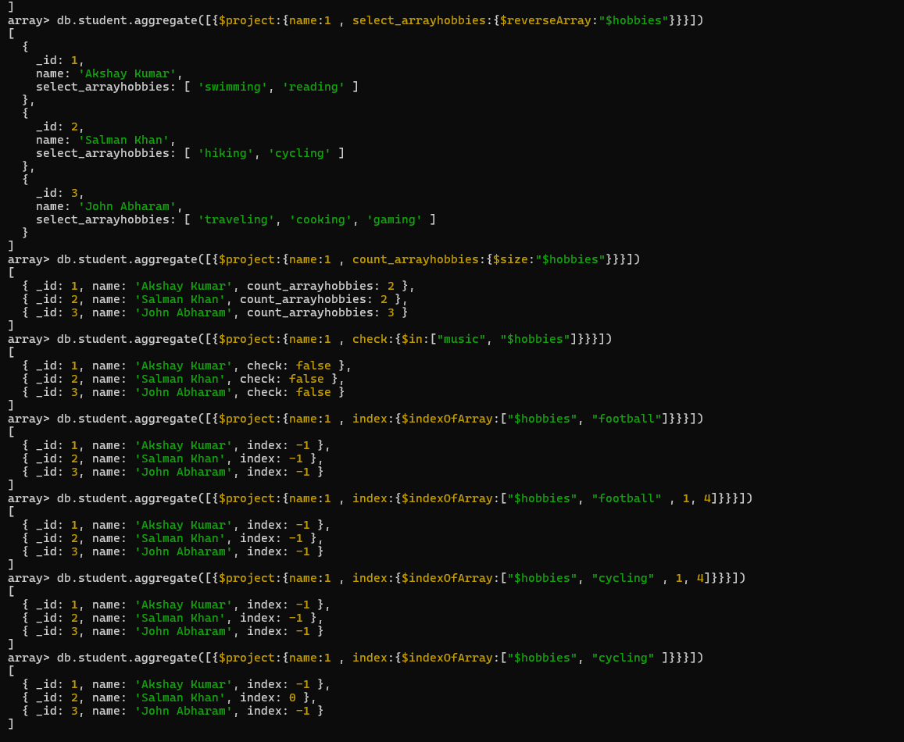

How would you count the number of hobbies each student has?

db.student.aggregate([{$project:{name:1 , count_arrayhobbies:{$size:"$hobbies"}}}])



Write a query to check whether the hobby music exists in each student's hobbies.

db.student.aggregate([{$project:{name:1 , check:{$in:["music", "$hobbies"]}}}])



Write a query to find the index of the hobby "football" in the hobbies array.

db.student.aggregate([{$project:{name:1 , index:{$indexOfArray:["$hobbies", "football"]}}}])



What would the result of $indexOfArray: ["$hobbies", "cycling", 1, 4] be for an array where "cycling" is at index 0?

db.student.aggregate([{$project:{name:1 , index:{$indexOfArray:["$hobbies", "cycling" , 1, 4]}}}])



Write a query to find the index of the hobby "cycling" in the hobbies array.

db.student.aggregate([{$project:{name:1 , index:{$indexOfArray:["$hobbies", "cycling"]}}}])